Train Loading Management System - Project Report
1. Introduction
The Train Loading Management System is a software solution designed to simulate real-world cargo train logistics. The project helps students develop practical skills in implementing data structures, dynamic memory management, and efficient algorithms using the C programming language. The system manages various types of cargo boxes and distributes them across train wagons efficiently while adhering to stacking and weight rules.

2. Project Objectives
Key Goals:
- Implement complex data structures like doubly linked lists.
- Utilize dynamic memory allocation to manage runtime data efficiently.
- Perform file I/O operations to save and load train statuses.
- Apply object-oriented design principles in C programming.
- Develop error handling and input validation techniques.

3. System Design and Functionalities
Functionalities
- Menu Interface
  - Load train status from file
  - Load material into wagons
  - Unload material from wagons
  - Display train and material statuses
  - Save train status to file
- Loading Rules
  - Materials must be loaded starting from the first suitable wagon.
  - Wagons are added dynamically only when needed.
  - Larger boxes cannot be placed on top of smaller ones.
- Unloading Rules
  - Materials are unloaded starting from the last wagon.
  - Empty wagons are removed, and IDs of remaining wagons are updated.

- Implementation Details

Key Algorithms
Loading Materials:
- The system ensures that heavier materials are not placed on top of lighter materials within a wagon.
- If a wagon becomes full, a new wagon is added dynamically, and loading continues.
Unloading Materials:
- Materials are removed starting from the last wagon.
- If a wagon becomes empty during unloading, it is removed, and the IDs of remaining wagons are updated.
Error Handling
- Checks for NULL pointers to avoid segmentation faults.
- Validates user input during material loading/unloading.
- Ensures that file operations handle errors (e.g., file not found, write failures).

5. Code Organization
File Structure:
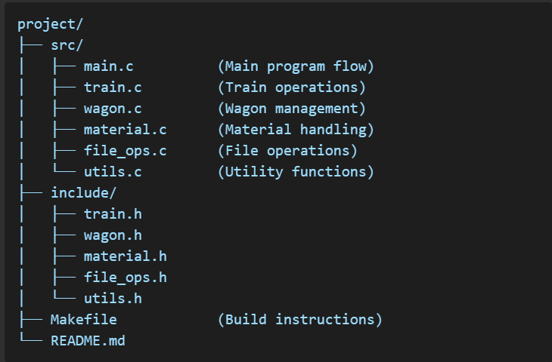

Responsibilities:
- main.c: Handles user input and menu navigation.
- train.c: Contains train-related operations, including material loading and unloading.
- wagon.c: Manages wagon creation, removal, and material updates.
- material.c: Manages material creation and quantity updates.
- file_ops.c: Handles saving and loading train status to/from files.
- utils.c: Provides error messages and utility functions.

6. Conclusion
The Train Loading Management System successfully demonstrates the use of advanced programming concepts in C, including doubly linked lists, dynamic memory allocation, and file handling. It provides a robust solution for managing cargo logistics while adhering to operational constraints and stacking rules. This project not only meets the functional requirements but also serves as a practical learning experience for implementing efficient algorithms and managing complex data structures.

BİLAL ÇOLAK – 2221251011 – SOFTWARE ENGINEERING
BURAK YILMAZ- 2221251047- SOFTWARE ENGINEERING

